Experiment 25: application experiment of relay
Relay is a kind of when input (electric, magnetic, acoustic, optical, thermal) reaches a certain value, the output will jump change type automatic control device. In life we often need to use weak control strong, it is often said that the small current control current problems, such as Arduino controller to control the fan like the electrical power we have to use the relay, for beginners, for safety reasons, in this experiment, we don't use high power appliances the, here we woodcarvings or the use of LED lights to complete the demonstration experiment.
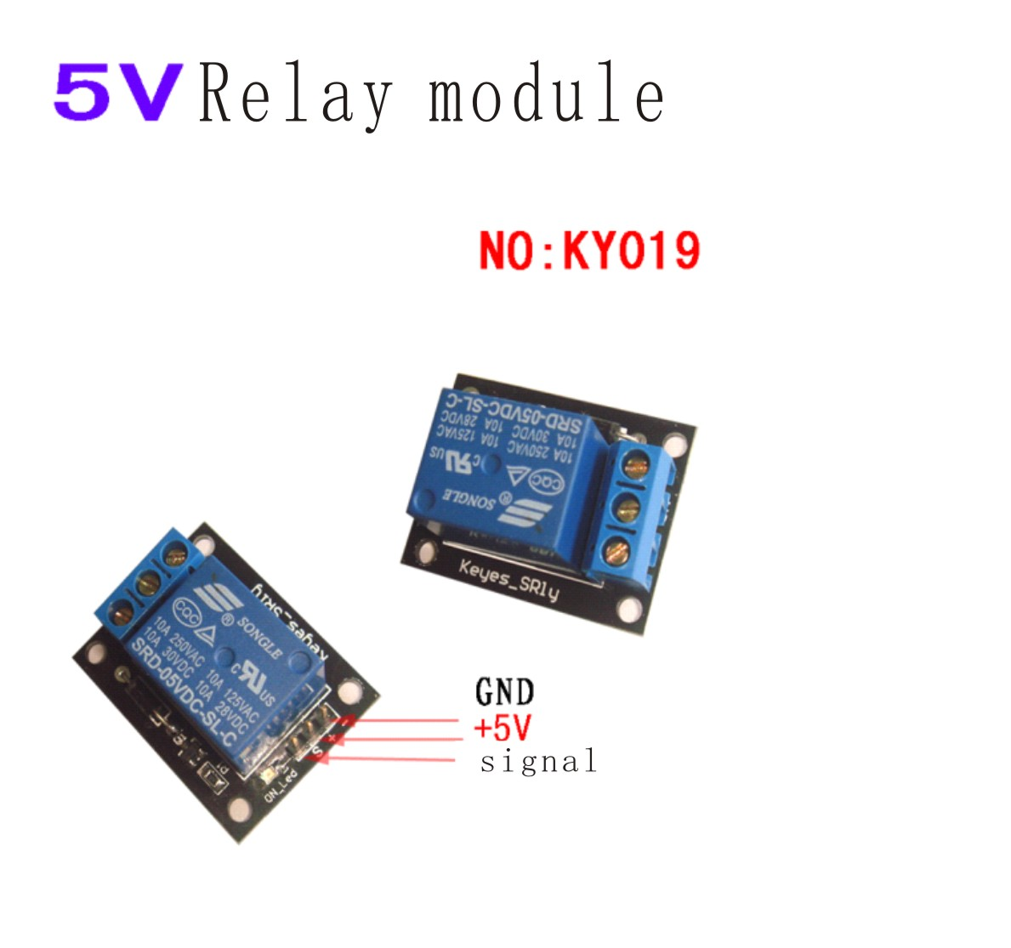

1, the new 5V relay module

2, can be used as a microcontroller development board module, can be used as a home appliance control

3, TTL control signal

4, the control of DC or AC signals, can control the 220V AC load.

5, there is a normally open and a normally closed contact

6, there is a power indicator light

7, control lamp, pull off bright, bright

8, the driver of the transistor to increase the relay coil, control the foot high impedance.

9, the control pin is pulled down to prevent the false action of the suspended relay
The relay signal belongs to digital signal module, we make the digital signal through the relay relay switching control of power equipment,
Here we use two LED lights as a large power equipment, we use Arduino controller of digital interface, the output high level delay 1 seconds after, the output low level 1 seconds, switch off opened a second and then is connected with a second.
Reference source program：
int RelayPin =8; //Definition of digital interface 8 connected to the base of the transistor
void setup()
{
pinMode(RelayPin, OUTPUT); //Define the RelayPin interface as the output interface

}
void loop()
{
digitalWrite(RelayPin, HIGH); //Drive relay closure
delay(1000); //Delay 1 seconds
digitalWrite(RelayPin, LOW); //Drive relay disconnect
delay(1000); //Delay 1 seconds
}
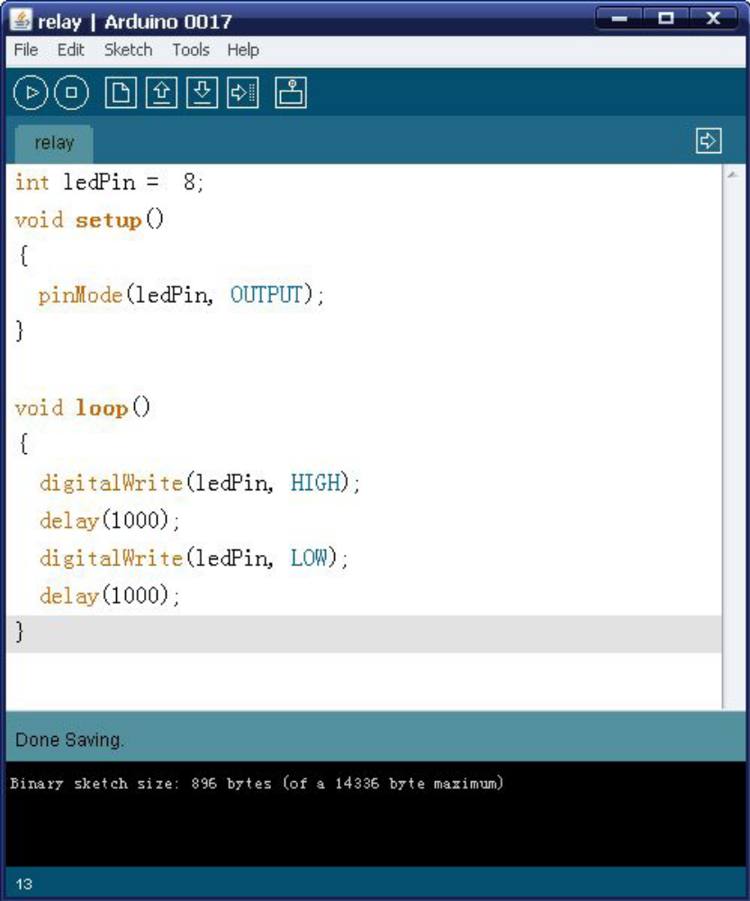
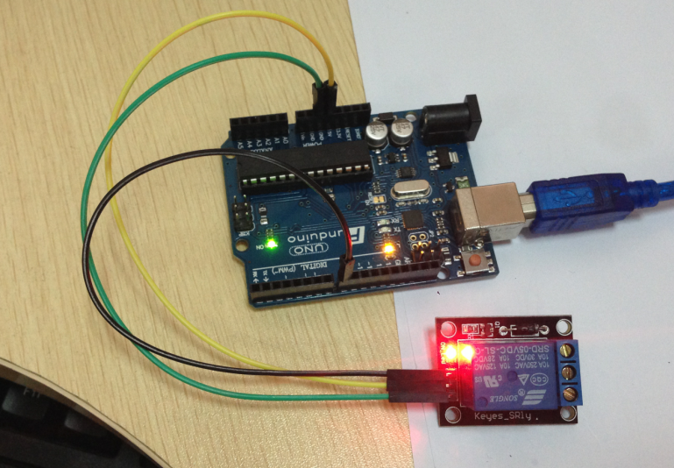
The relay module, we can control the 220V lamp, as simple as control LED. Download the complete program we can see the red and green lights turns flashing the. This experiment also ends, I hope everybody started mind used to their own interactive works.

